
Task 3
Network Intrusion Detection System
Student Name | Amir Khan
Student ID | CA/DF1/149163
Internship Track | Cyber security internship
Submission Date | 07/07/2026
Week /Task | Task 3

Overview
A Network Intrusion Detection System (NIDS) monitors network traffic and detects suspicious or malicious activities. It analyzes packets moving across the network and compares them against predefined rules or signatures. When suspicious traffic is detected, it generates an alert for the security analyst.
In this lab, I will install and configure Suricata on Windows, monitor network traffic, create custom detection rules, generate alerts, and verify that the alerts are triggered correctly.

Learning Objectives
By the end of this task, I will be able to:
- Install and configure Suricata as a NIDS on a Linux environment (WSL).
- Write and customize Suricata detection rules for suspicious/malicious traffic.
- Monitor live network traffic and generate real-time alerts.
- Understand and implement basic response mechanisms for detected intrusions.
- (Optional) Visualize alerts using a dashboard or log analysis tool.

Lab Environment & Prerequisites
Environment:
- Windows 10
- WSL (Windows Subsystem for Linux) — Ubuntu distro (same one used before for Suricata)
- Suricata installed inside WSL
- Internet/network access for live traffic capture
Prerequisites:
- WSL already installed and working (confirm distro version)
- Basic familiarity with Suricata rule syntax (already covered before)
- Admin/sudo access inside WSL
- A network interface to monitor (WSL uses a virtual adapter, so we'll check what's available via ip a)
- Suricata config file: /etc/suricata/suricata.yaml
- Suricata rules path: /etc/suricata/rules/

Step 1: Install Suricata and Load Rules
I have already installed Ubuntu now we will install suricata and than check the version of suricata.
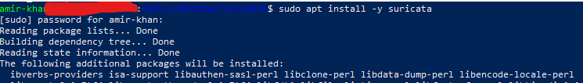
Now check version,
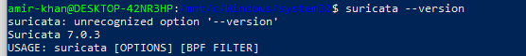
Now update sucricata,
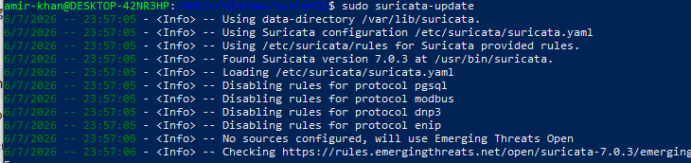

Step 2: Suricata Configuration Setup
Now I will setting Network for config file suricata.yaml
1.First backup of config file:
2.Now set Home net:
Its already setuped,
3.set Interface:
Its already setuped
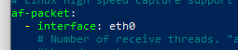

Step 3: Config Verify + Rules Setup:
First we will test suricata config.
1 suricata config test:
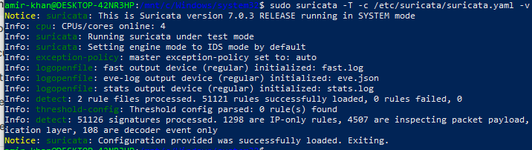
Its Successfully done
2. check default rule
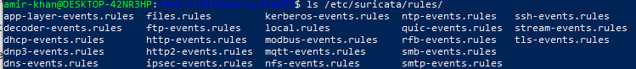
These are the rule now suricata have
3. rule file enable in config:
Its already enabled
5.Custom Rule Creation:
# Rule 1: Detect ICMP Ping (basic connectivity/recon test)
alert icmp any any -> $HOME_NET any (msg:"ICMP Ping Detected"; sid:1000001; rev:1;)

# Rule 2: Detect Nmap-style SYN scan (common port scanning technique)
alert tcp any any -> $HOME_NET any (msg:"Possible Nmap SYN Scan Detected"; flags:S; threshold: type both, track by_src, count 20, seconds 3; sid:1000002; rev:1;)

# Rule 3: Detect HTTP traffic to suspicious User-Agent (e.g. common scanning tools)
alert http any any -> $HOME_NET any (msg:"Suspicious User-Agent Detected"; http.user_agent; content:"nmap"; nocase; sid:1000003; rev:1;)

# Rule 4: Detect FTP login attempt (plaintext credentials risk)
alert tcp any any -> $HOME_NET 21 (msg:"FTP Connection Attempt Detected"; sid:1000004; rev:1;)

# Rule 5: Detect DNS query to a suspicious/test domain (example for malicious domain detection)
alert dns any any -> $HOME_NET any (msg:"DNS Query Detected"; dns.query; content:"malicious-test.com"; nocase; sid:1000005; rev:1;)
I have created these five rules for detection,

Step 6: Run on Live traffic Suricata
sudo suricata -c /etc/suricata/suricata.yaml -i eth0
Now run Suricata in live mode by this command and the as it run by the second command in second terminal
ps aux | grep suricata
Step 7: Test Traffic Generate
In the second terminal Started Suricata in live capture mode on interface eth0 to monitor real-time network traffic
Test 1: ICMP Rule (Ping Test):
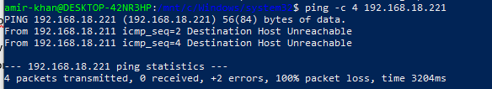
Test 2: SYN Scan Rule (Nmap style)
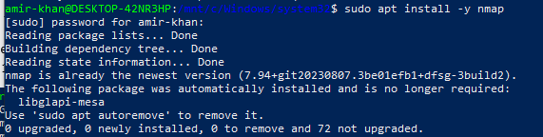
Test 3: FTP Rule

Step 8: Check Alerts :
Generated test traffic (ping and FTP connection attempt) and confirmed Suricata successfully detected and logged both events with correct SIDs and timestamps.
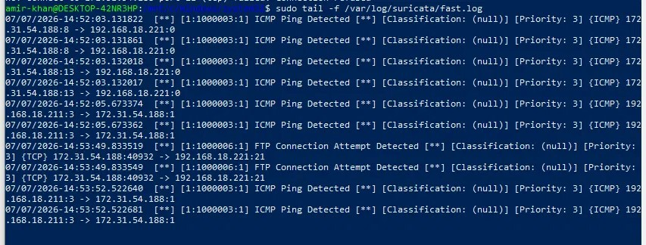
Check DNS Rules:
Performed a DNS query test for a simulated malicious domain and confirmed Suricata's DNS detection rule triggered correctly."
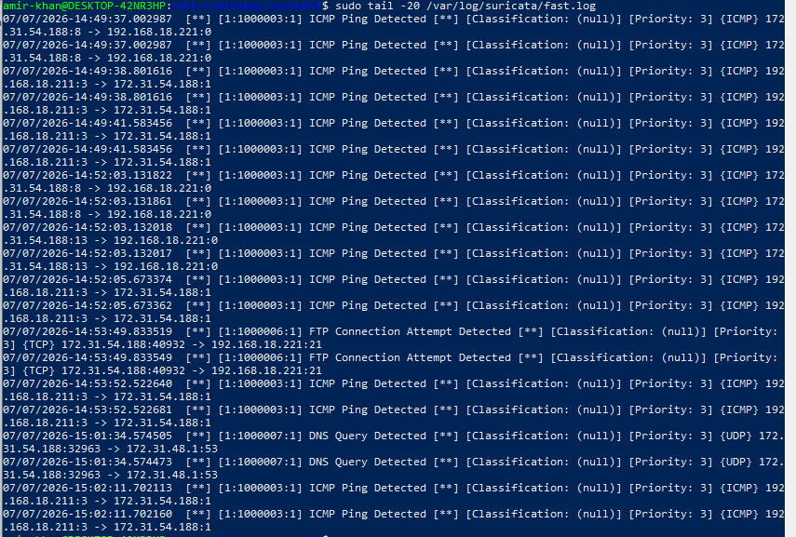
Step 9: Response Script Banana (Log + Record Attacker IP)
Developed a custom incident response script that continuously monitors Suricata's fast.log, extracts the source IP and alert message for each detected event, and records them with timestamps into a dedicated incident_response.log file for tracking and reporting purposes.
1. Create Script file
BY this command:
sudo nano /home/amir-khan/incident_response.sh
2.Paste Script
#!/bin/bash
# Incident Response Script - Monitors Suricata fast.log for alerts
# and records attacker IP, timestamp, and alert type

LOGFILE="/var/log/suricata/fast.log"
OUTPUT="/home/amir-khan/incident_response.log"

echo "Incident Response Monitoring Started: $(date)" >> "$OUTPUT"

tail -Fn0 "$LOGFILE" | while read line
do
if echo "$line" | grep -q "\[\*\*\]"; then
ALERT_MSG=$(echo "$line" | grep -oP '(?<=\] ).*?(?= \[\*\*\])' | head -1)
SRC_IP=$(echo "$line" | grep -oP '(?<=\}\s)[0-9.]+(?=:[0-9]+\s->)')
TIMESTAMP=$(date +"%Y-%m-%d %H:%M:%S")

echo "[$TIMESTAMP] ALERT: $ALERT_MSG | SOURCE IP: $SRC_IP" >> "$OUTPUT"
echo "Incident recorded: $ALERT_MSG from $SRC_IP"
fi
done
3.Giving permission to script:
By chmod
4. Run the Script:
Developed a custom incident response script that continuously monitors Suricata's fast.log, extracts the source IP and alert message for each detected event, and records them with timestamps into a dedicated incident_response.log file for tracking and reporting purposes
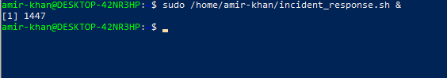
This is the result